

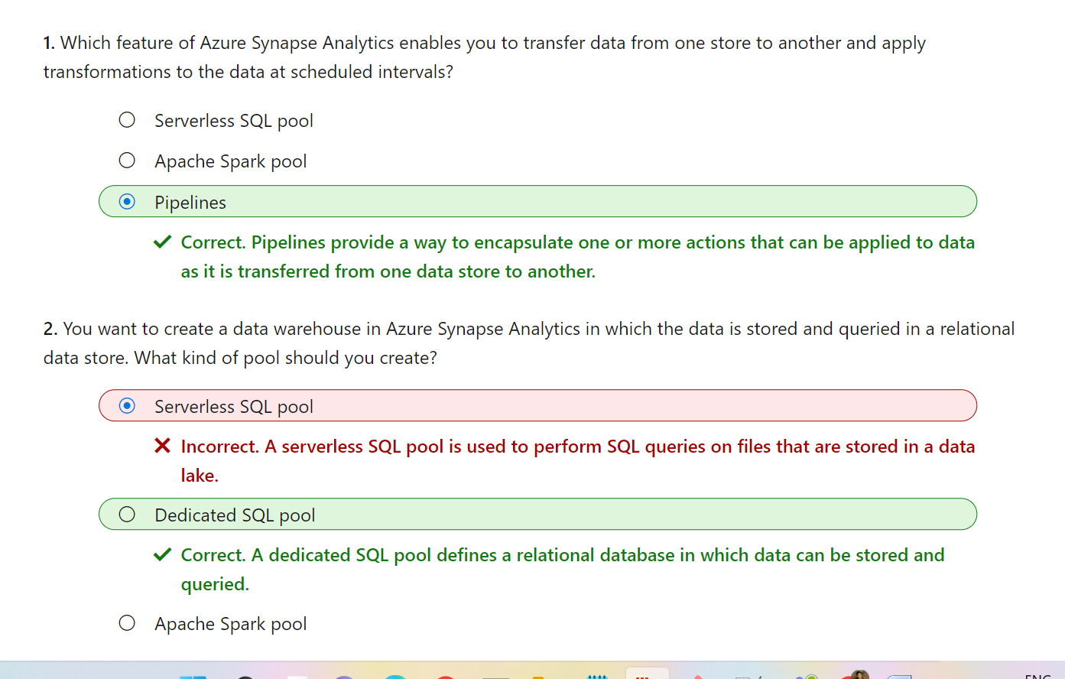

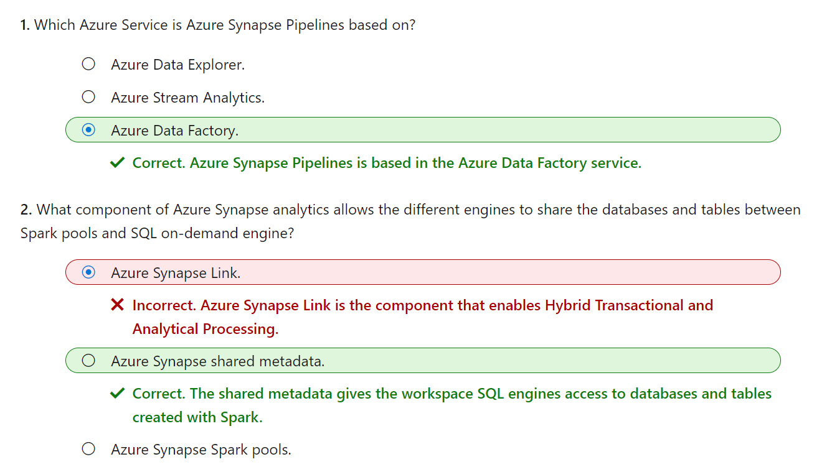

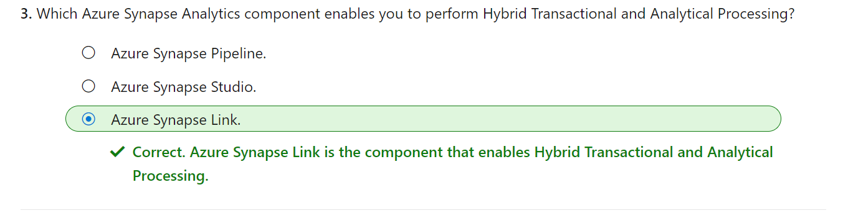

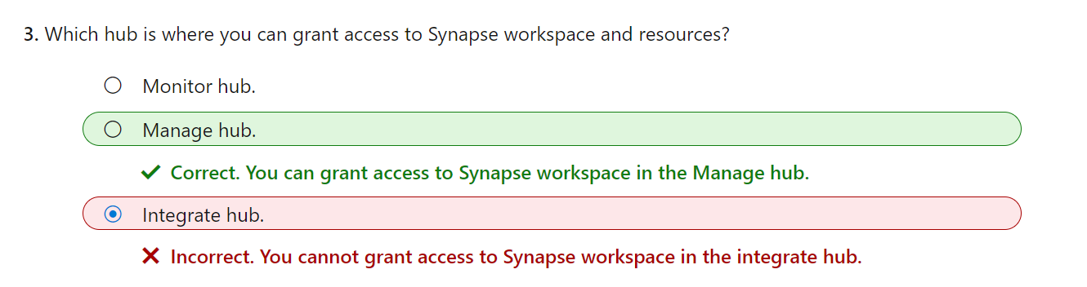

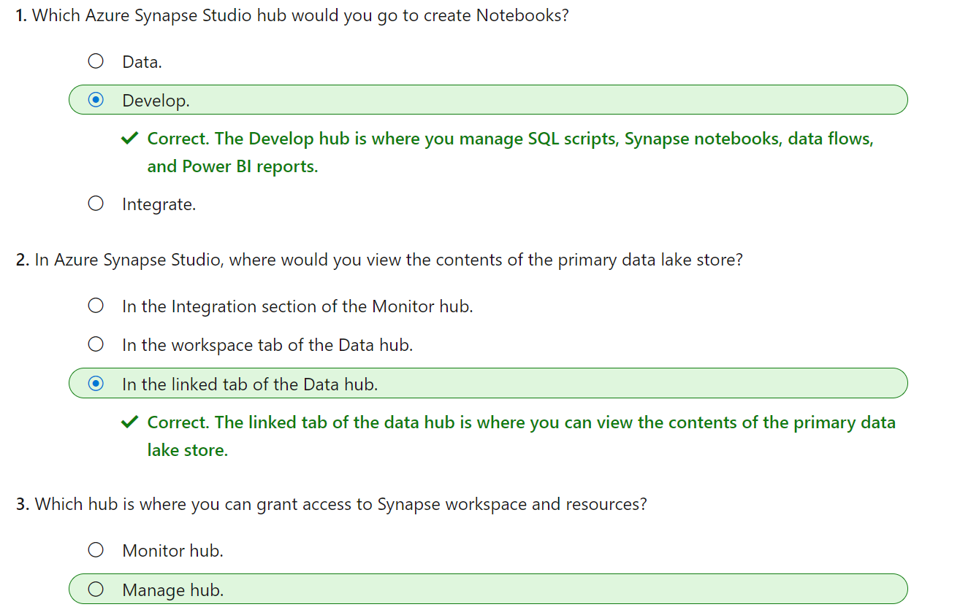



Note:

* Server less pool is to perform SQL queries on files that are stored in a data lake
* Apache SQL POOL to process data in files in a data lake. So it will create notbooks of python code and embed notes using markdown
* SQL POOL A dedicated SQL pool defines a relational database in which data can be stored and queried.

Exercise on Synapse:

[mslearn-synapse (microsoftlearning.github.io)](https://microsoftlearning.github.io/mslearn-synapse/Instructions/Labs/01-Explore-Azure-Synapse.html)

Documentation on synapse:

[What is Azure Synapse Analytics? - Azure Synapse Analytics | Microsoft Learn](https://learn.microsoft.com/en-us/azure/synapse-analytics/overview-what-is)

Dedicated SQL Pools is a collection of analytic resources that are being provisioned when using Synapse SQL.

When you need predictable performance and cost to reserve processing power for data permanently stored in SQL tables in a data warehouse is the best approach to take.

Serverless is quite opposite to dedicated model where unplanned or ad hoc workloads that the diagnostice analytics apporach would generate to perform data exploration and data virtualization.

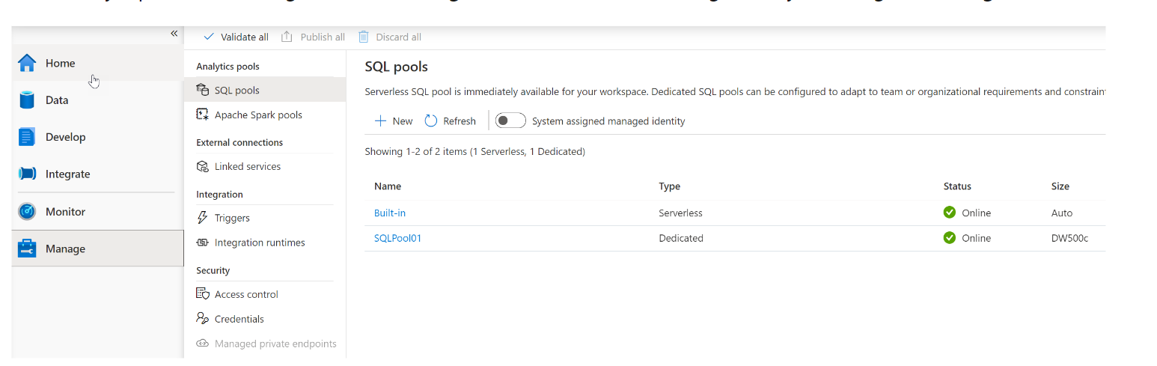

* Apache Spark Pool name: Sparkpool01
* Node size: Small (4 vCPU / 32 GB)
* Autoscale: Disabled
* Number of Nodes: 8

